ASSIGNMENT 4
Implementation of AWS Identity and Access Management (IAM)
The primary objective of this assignment is to demonstrate how to create a secure IAM user in AWS, assign specific managed policies (AmazonS3FullAccess), and verify that the user can only access authorized services while being restricted from others (like EC2 and Billing).

Step 1: Accessing IAM Users Dashboard
The AWS Identity and Access Management (IAM) dashboard. The user is on the "Users" page, which currently shows zero users. The "Create user" button is highlighted to start the process.
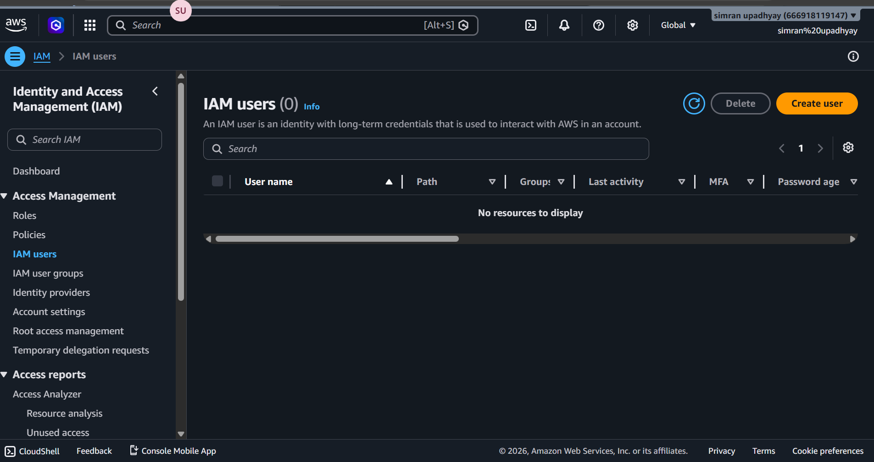

Step 2: Specifying User Details
In this step, the user name is set as “simran”. The option "Provide user access to the AWS Management Console" is checked, and "Autogenerated password" is selected for the login credentials.
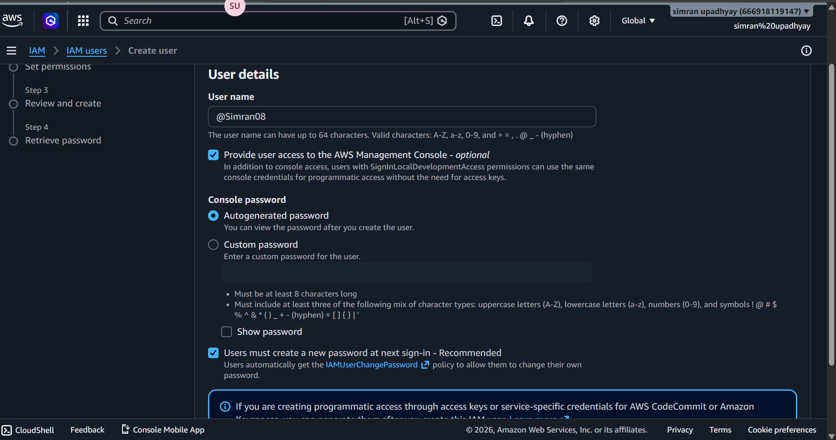

Step 3: Permission Options
This "Set permissions" phase. Three options are visible: "Add user to group," "Copy permissions," and "Attach policies directly." The "Add user to group" option is initially highlighted.

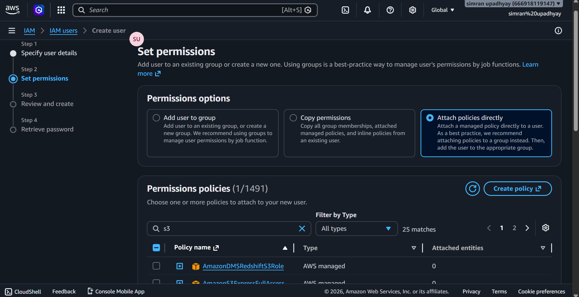
Step 4: User Created Successfully
A green success banner confirms that the user has been created. This page provides the Console sign-in URL, the username, and a hidden password that can be revealed or downloaded as a .csv file.

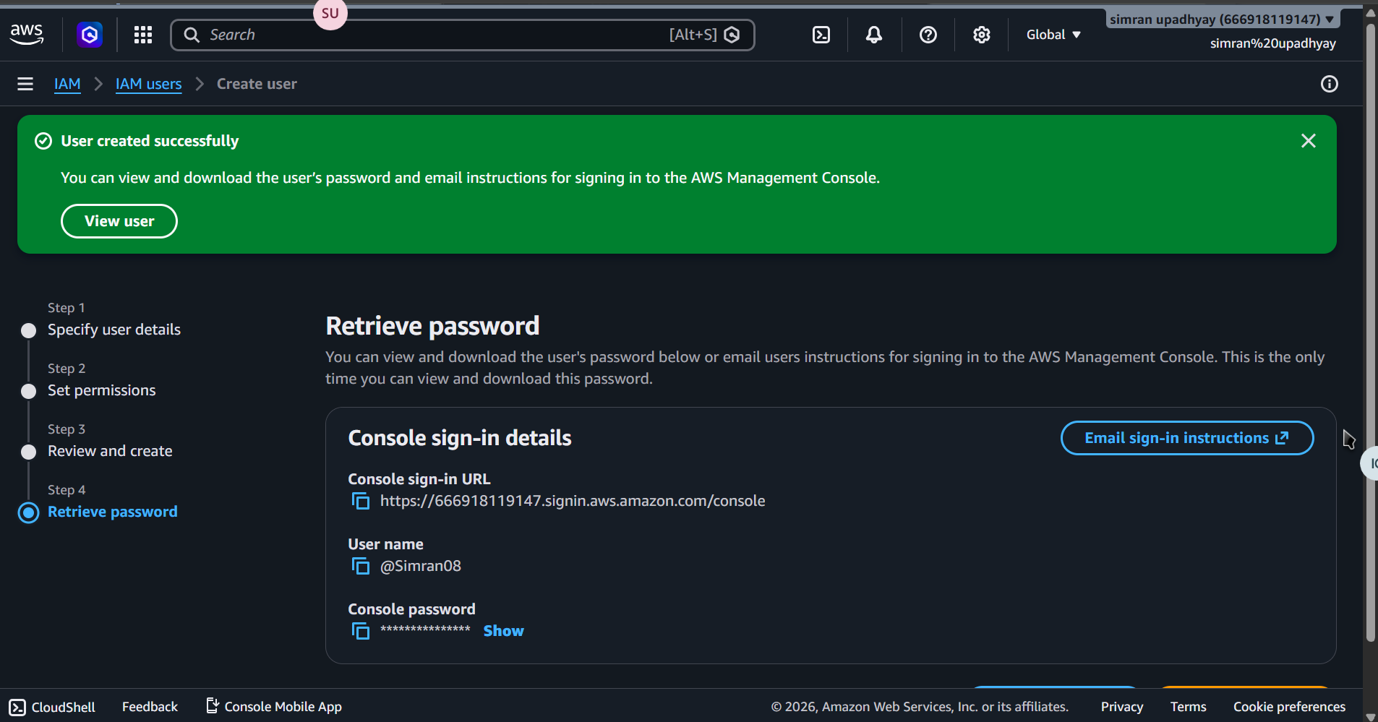

Step 5: IAM User Sign-in
The official AWS login page is shown. The Account ID, IAM username (ranjeet), and the autogenerated password are entered into the fields. The user is clicking "Sign in."
